React Redux:
Redux is a predictable state container for typescript apps based on the Flux design pattern. Redux can be used together with React, or with any other view library. It is tiny (about 2kB) and has no dependencies.

Redux follows three fundamental principles:

Single source of truth:
The state of your whole application is stored in an object tree within a single store. The single state tree makes it easier to keep track of changes over time and debug or inspect the application.

State is read-only:
The only way to change the state is to emit an action, an object describing what happened. This ensures that neither the views nor the network callbacks will ever write directly to the state.

Changes are made with pure functions:
To specify how the state tree is transformed by actions, you write reducers. Reducers are just pure functions that take the previous state and an action as parameters, and return the next state.

React Concept and Architecture :
Let us assume our application’s state is described by a plain object called initialState which is as follows −
const initialState: {
isLoading: boolean,
items: any[],
hasError: boolean
} = {
isLoading: false,
items: [],
hasError: false
};

Every piece of code in your application cannot change this state. To change the state, you need to dispatch an action.

What is an action?
An action is a plain object that describes the intention to cause change with a type property. It must have a type property which tells what type of action is being performed. The command for action is as follows −

const requestItems = (): { type: string, isLoading: boolean } => {
return {
type: 'ITEMS_REQUEST',
isLoading: true
}
}

export default requestItems;

Actions and states are held together by a function called Reducer. An action is dispatched with an intention to cause change. This change is performed by the reducer. Reducer is the only way to change states in Redux, making it more predictable, centralised and debuggable. A reducer function that handles the ‘ITEMS_REQUEST’ action is as follows −
const reducer = (state: State = initialState, action: Action): State => {
switch (action.type) {
case 'ITEMS_REQUEST':
return Object.assign({}, state, {
isLoading: action.isLoading
})
default:
return state;
}
}

Redux has a single store which holds the application state. If you want to split your code on the basis of data handling logic, you should start splitting your reducers instead of stores in Redux.
We will discuss how we can split reducers and combine it with stores later in this tutorial.
Redux components are as follows −
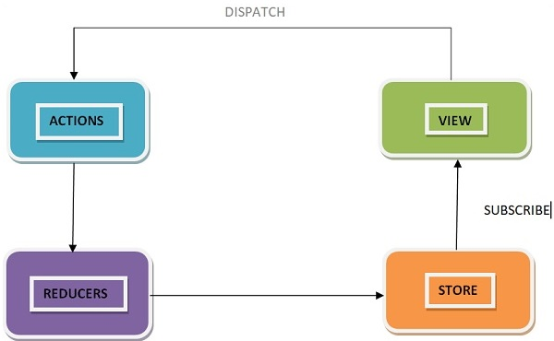

Redux DataFlow :

Redux follows the unidirectional data flow. It means that your application data will follow a one-way binding data flow. As the application grows & becomes complex, it is hard to reproduce issues and add new features if you have no control over the state of your application.
Redux reduces the complexity of the code, by enforcing the restriction on how and when state updates can happen. This way, managing updated states is easy. We already know about the restrictions as the three principles of Redux. Following diagram will help you understand Redux data flow better −
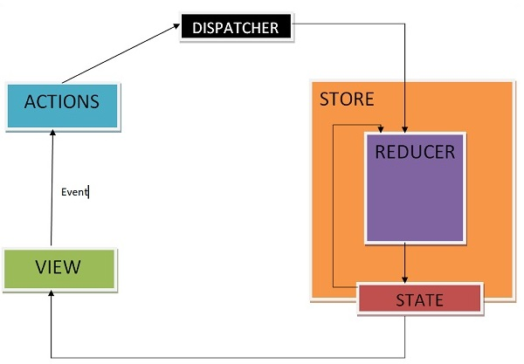
- An action is dispatched when a user interacts with the application.
- The root reducer function is called with the current state and the dispatched action. The root reducer may divide the task among smaller reducer functions, which ultimately returns a new state.
- The store notifies the view by executing their callback functions.
- The view can retrieve updated state and re-render again.

Redux Store:

A store is an immutable object tree in Redux. A store is a state container which holds the application’s state. Redux can have only a single store in your application. Whenever a store is created in Redux, you need to specify the reducer.
Let us see how we can create a store using the createStore method from Redux. One need to import the createStore package from the Redux library that supports the store creation process as shown below −
import { createStore, Store } from 'redux';
import reducer from './reducers/reducer';

const store: Store = createStore(reducer);

React Hooks:

Hooks is a new feature that lets you use state and other React features without writing a class.

Basic Hooks:-
useState:
This hook returns a stateful value and a function to update it. Originally, we had to initialise the apps state separately and then use the setState function to update the state’s value.

useState:
const [state, setState] = useState(initialState);

Returns a stateful value, and a function to update it.
During the initial render, the returned state (state) is the same as the value passed as the first argument (initialState).

The setState function is used to update the state. It accepts a new state value and enqueues a re-render of the component.

setState(newState);

During subsequent re-renders, the first value returned by useState will always be the most recent state after applying updates.

Let's see an example of useState hook example:

import React, { useState } from "react";
import ReactDOM from "react-dom";

interface AppProps {}

const App: React.FC<AppProps> = () => {
const [count, setCount] = useState<number>(0);

return (
<div className="App">
<h1>Hello CodeSandbox</h1>
<h2>You clicked {count} times!</h2>

<button onClick={() => setCount(count - 1)}>Decrement</button>
<button onClick={() => setCount(count + 1)}>Increment</button>
</div>
);
}

const rootElement: HTMLElement | null = document.getElementById("root");
ReactDOM.render(<App />, rootElement);

useEffect:-
This hook takes a function that contains code (fetching data or subscribing to a service) and returns a function that will be executed every time before the effect runs and when the component is unmounted — in order to re-initialize itself from the last iteration.

useEffect:
useEffect(didUpdate);

Let's see an example of useEffect hook example:

import React, { useEffect, useState } from "react";
import ReactDOM from "react-dom";

interface CounterProps {}

const Counter: React.FC<CounterProps> = () => {
const [count, setCount] = useState<number>(0);

useEffect(() => {
setTimeout(() => {
console.log(`You clicked ${count} times`);
}, 3000);
});

return (
<div>
<p>You clicked {count} times</p>
<button onClick={() => setCount(count + 1)}>Click me</button>
</div>
);
};

const rootElement = document.getElementById("root");
ReactDOM.render(<Counter />, rootElement);

useContext:-
This hook accepts a context object and returns the current context value, as given by the nearest context provider for the given context.

Ex:
import React, { createContext, FC } from 'react';
import ReactDOM from 'react-dom';
import './App.css';
import './index.css';

interface NameContextProps {
value: string;
}

const NameContext = createContext<NameContextProps>({ value: "" });

const App: FC = () => {
return (
<NameContext.Provider value={{ value: "Rajat" }}>
<div className="App">
<NameContext.Consumer>
{value => <h1>Hello! My Name is {value.value}!</h1>}
</NameContext.Consumer>
</div>
</NameContext.Provider>
);
};

ReactDOM.render(<App />, document.getElementById('root'));

Here, we are using the createContext() function to create a new instance of the context named NameContext. This instance is connect to values: Provider and Consumer.

The NameContext.Provider component is used to initialise the data. Then we have to wrap our content in a NameContext.Consumer and use the render props pattern of passing a function as a child in order to retrieve the value and display it.

import React, {useContext} from 'react';

Then, replace the NameContext.Consumer component and the whole h1 tag inside it with a simple Greet component, as shown below:
import React, { FC } from 'react';
import NameContext from './NameContext';
import Greet from './Greet';

const App: FC = () => {
return (
<NameContext.Provider value={"Rajat"}>
<div className="App">
<Greet/>
</div>
</NameContext.Provider>
)
}

export default App;

We haven’t written this Greet component yet, so let’s take care of that right below the App component as shown below:

import React, { useContext } from 'react';

interface GreetProps {
value: string;
}

const Greet: React.FC<GreetProps> = ({ value }) => {
return <h1>Hello! My Name is {value}</h1>;
}

export default Greet;

And That’s All! We simply call the useContext hook on the value, pass in the NameContext object to it and we can then use the value anywhere inside that component.

Higher order components are typescript functions used for adding additional functionalities to the existing component. These functions are pure, which means they are receiving data and returning values according to that data. If the data changes, higher order functions are re-run with different data input. If we want to update our returning component, we don't have to change the HOC. All we need to do is change the data that our function is using.
Higher Order Component (HOC) is wrapping around "normal" component and provide additional data input. It is actually a function that takes one component and returns another component that wraps the original one.
Let us take a look at a simple example to easily understand how this concept works. The MyHOC is a higher order function that is used only to pass data to MyComponent. This function takes MyComponent, enhances it with newData and returns the enhanced component that will be rendered on the screen.
import React, { Component, FC } from 'react';

interface NewData {
data: string;
}

const newData: NewData = {
data: 'Data from HOC...',
}

const MyHOC = <P extends object>(ComposedComponent: FC<P>) => class extends Component<P> {
state = {
data: newData.data
};

componentDidMount() {
this.setState({
data: newData.data
});
}

render() {
return <ComposedComponent {...this.props} {...this.state} />;
}
};

interface MyComponentProps {
data: string;
}

class MyComponent extends Component<MyComponentProps> {
render() {
return (
<div>
<h1>{this.props.data}</h1>
</div>
)
}
}

export default MyHOC(MyComponent);

